DAA EXPERIMENT -3
GRAPH TRAVERSALS

NAME: KODALI SAHITH
ROLL NO: CH.SC.U4CSE24223
SECTION: CSE-C
DATE: 07-12-2025

- DFS(Depth First Search):

CODE:

#include <stdio.h>

int adj[10][10], visited[10], n;

void dfs(int v) {
int i;

printf("%d ", v);
visited[v] = 1;

for(i = 0; i < n; i++) {
if(adj[v][i] == 1 && visited[i] == 0) {
dfs(i);
}
}
}

int main() {
int i, j, start;

printf("Enter number of vertices: ");
scanf("%d", &n);

printf("Enter adjacency matrix:\n");
for(i = 0; i < n; i++) {
for(j = 0; j < n; j++) {
scanf("%d", &adj[i][j]);
}
}

printf("Enter starting vertex: ");
scanf("%d", &start);

printf("DFS traversal: ");
dfs(start);

printf("\n");
return 0;
}

OUTPUT:

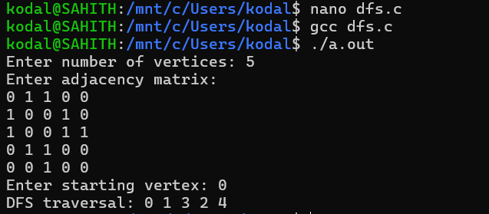

- BFS(Breadth First Search):

CODE:

#include <stdio.h>

int adj[10][10], visited[10], queue[10];
int n, front = -1, rear = -1;

void bfs(int start) {
int i;

queue[++rear] = start;
visited[start] = 1;

while(front != rear) {
int v = queue[++front];
printf("%d ", v);

for(i = 0; i < n; i++) {
if(adj[v][i] == 1 && visited[i] == 0) {
queue[++rear] = i;
visited[i] = 1;
}
}
}
}

int main() {
int i, j, start;

printf("Enter number of vertices: ");
scanf("%d", &n);

printf("Enter adjacency matrix:\n");
for(i = 0; i < n; i++) {
for(j = 0; j < n; j++) {
scanf("%d", &adj[i][j]);
}
}

printf("Enter starting vertex: ");
scanf("%d", &start);

printf("BFS traversal: ");
bfs(start);

printf("\n");
return 0;
}

OUTPUT:

